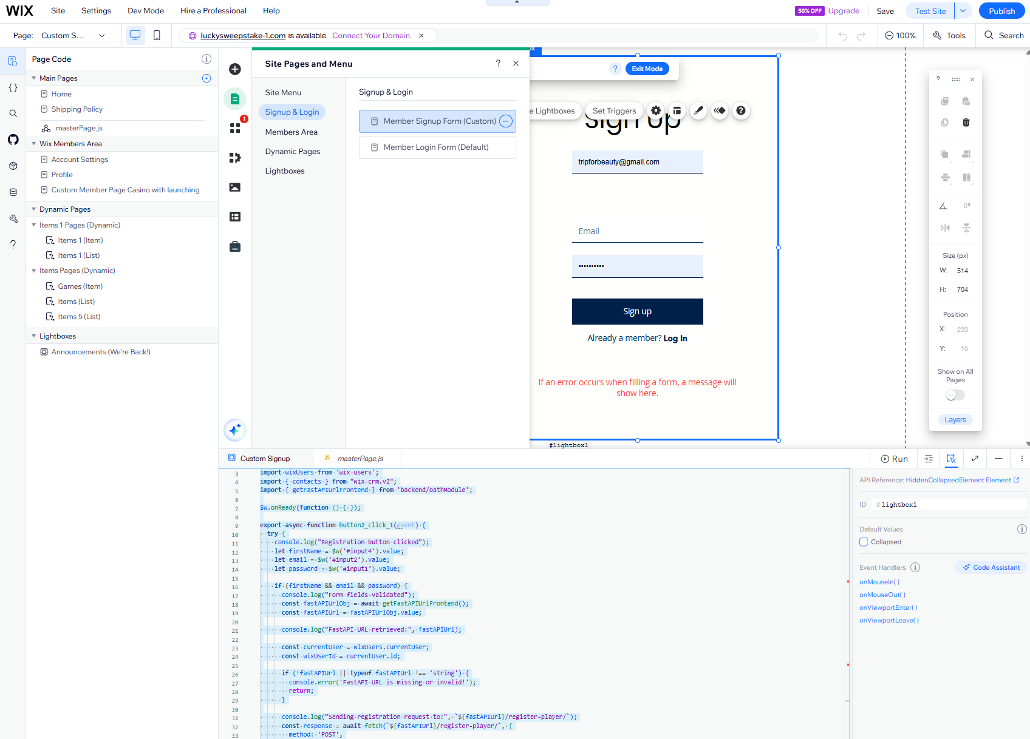

DB
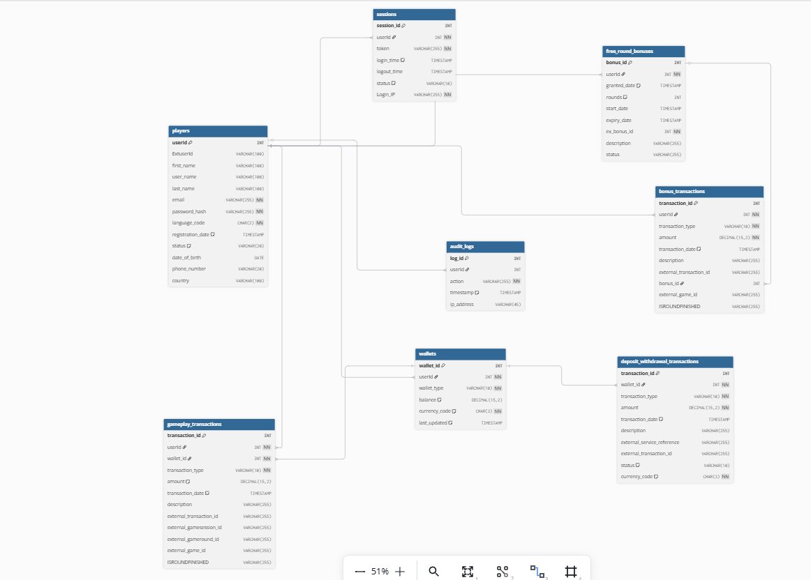

nGrok

CMD Admin
ngrok http http://localhost:8000

Git commands:

Instructions
- Open your .gitignore file.
- Add a specific exception rule: You'll use an exclamation mark ! to create a "negation" rule. This tells Git to re-include a file or folder that was previously excluded by a broader pattern.
Your .gitignore file should look like this:
# Virtual environment
.venv/

# Allow specific files inside the .venv folder
!.venv/database.py
!.venv/models.py
!.venv/routers/
  - .venv/ tells Git to ignore the entire .venv directory and all its contents.
  - !.venv/database.py tells Git to track the database.py file specifically.
  - !.venv/models.py tells Git to track the models.py file specifically.
  - !.venv/routers/ tells Git to track the routers folder and its contents.
- Force add the files: Now that you've told Git to make an exception, you need to force-add these files and folders. This overrides the default behavior and adds them to your repository.
Bash
git add -f .venv/database.py
git add -f .venv/models.py
git add -f .venv/routers
- Commit and Push: Finally, commit these changes and push them to your remote repository.
Bash
git commit -m "Add core project files from .venv folder"
git push

